Process Flow:-Dol Update Import

Step 1
Select Dol Update option From BIS Menu.

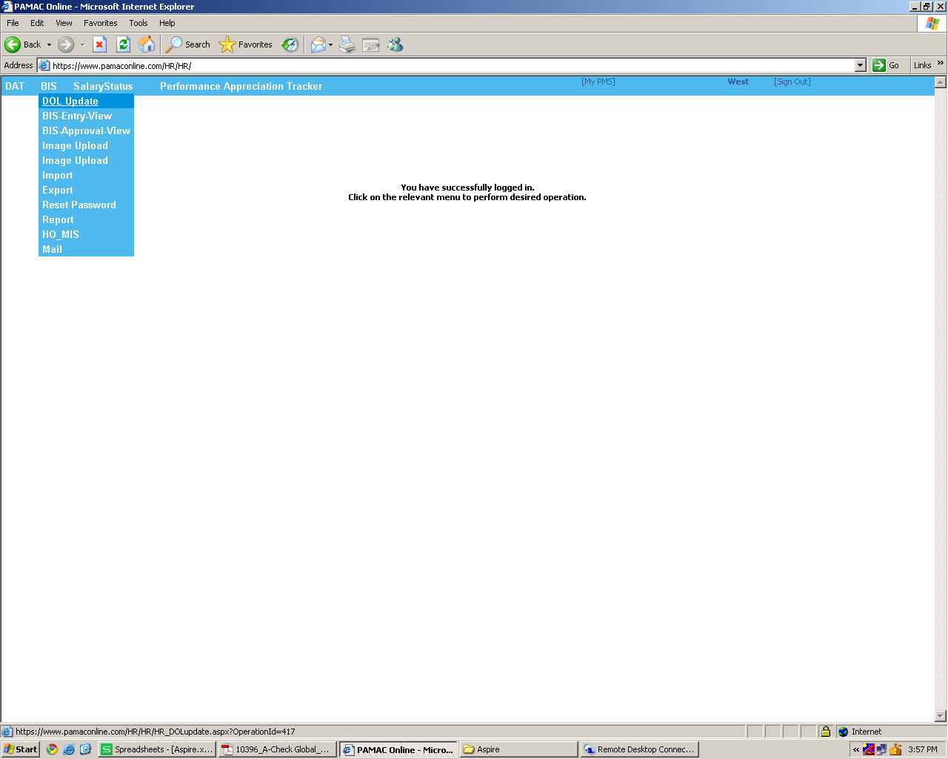

Step 2:
See The Upload option at end of page.
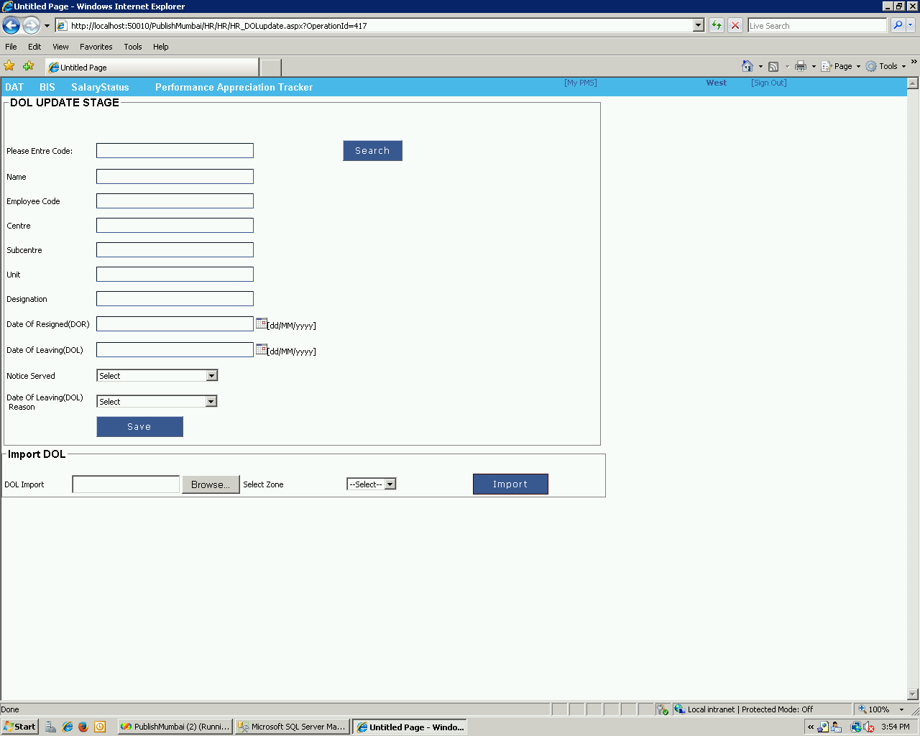

Step 3:
Please Select the Xls File and Select The Zone (Location).
